**Barbara Hepworth.**

**Sculpture for a Modern World**

**(22 May – 28 August 2016)**

**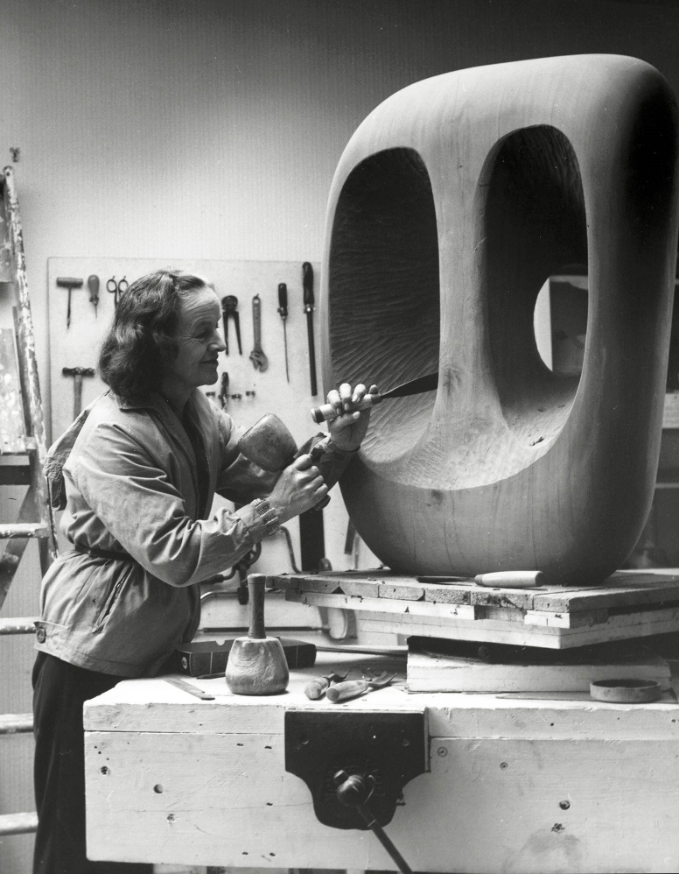**

*Barbara Hepworth in the Palais de la Danse studio, St Ives, at work on the wood carving Hollow Form with White Interior* 1963

Contents

Press Release: "Barbara Hepworth: Sculpture for a Modern World" 3

General Information 6

Press Photographs: "Barbara Hepworth: Sculpture for a Modern World" 8

Preview of Coming Exhibitions for 2016/2017 12

»[…] seeing his [Arp’s] work for the first time freed me of many inhibitions and this helped me to see the figure in landscape with new eyes. Perhaps in freeing himself from material demands his idea transcended all possible limitations.«

**Barbara Hepworth. Sculpture for a Modern World**

**(Exhibition duration: 22 May - 28 August 2016)**

**Arp Museum is honoring Barbara Hepworth (1903-1975), one of the 20th century's most successful woman sculptors, with a large retrospective show. »This important modernist artist is being shown in Germany for the first time again in 50 years, and I am delighted that Arp Museum is mounting this first-rate exhibition in Rhineland-Palatinate as the result of a cooperation with the Tate Britain and the Dutch Kröller-Müller Museum,« states Dr. Jürgen Pföhler, Ahrweiler County Commissioner and the Deputy Chairman of the Landes-Stiftung Arp Museum Bahnhof Rolandseck.**

**Large-scale Retrospective Showing of Works by Barbara Hepworth**

She is reckoned among the great sculptors of the mid-20th century: The British artist Barbara Hepworth (born 1903 in Wakefield, died 1975 in St. Ives). With her abstract, seemingly-organic sculptures, she developed an entirely individual modern language of forms. For the first time in Germany in 50 years, this exhibition pays tribute to her extraordinary oeuvre by presenting her in a monographic exhibition.

In the 1950s and 60s, Barbara Hepworth gained international renown with exhibitions in Europe, the USA, South America, and Asia. After her death in 1975, however, she came to be considered mainly in the context of British art, which relegated to the background her importance for the international development of modern sculpture. This survey exhibition shows how, even as a student in the 1920s, Hepworth had gained early recognition before going on to become one of the most successful woman sculptors of her day, and proceeding to decisively influence post-war European art.

This large-scale retrospective show was organized by Tate Britain, London, in cooperation with the Kröller-Müller Museum, Otterlo, and Arp Museum Bahnhof Rolandseck. It comprises more than 100 works; in addition to numerous sculptures, the show also includes pieces on display now for the first time, such as textile designs, drawings, collages and photograms as well as film footage and photographs of the artist working in her studio. To supplement the exhibition, around 30 works by Hepworth's artist colleagues, such as Jacob Epstein, Henry Moore and Ben Nicholson, are being shown.

**Stages of her artistic development**

Based on five groups of work, the exhibition traces the development of the artist from early figurative sculptures in stone and wood up to the abstraction revealed in her iconic works in wood and the late, large-format bronzes. Thus, it illustrates her interest in using various sculptural materials and also shows how she dealt with formal aspects of sculpture as a medium.

»Direct Carving«, where the material is treated directly, without the use of preparatory models, was a technique Hepworth advanced considerably from 1929 onwards. Although at the beginning she mostly worked in stone and marble - up to this time a purely male-dominated field - she now concentrated more on carving wood. Starting in the early 1930s she began to detach herself from the figurative animal and human portrayals, now developing an abstract language of forms.

Hepworth's works executed in wood, characterized by rounded forms and smooth surfaces, reveal her interest in light and the surface as well as in the relationship between sculpture and space. For example, she collaged several sculptural elements on a plinthe (here a flat base) in order to fathom the relationship of the figures to one another within the limited space. A central feature of her works is the »piercings« in the sculptures themselves - interim spaces, in which the work and the surroundings fuse to become an inseparable entity.

By using differently colored surfaces and adding »strings« that structure the interim spaces, these open forms become compositions in three-dimensional space. Drawings in color illustrate just how much the sculptures with their myriad views differ from their two-dimensional designs on paper. One important group of works in this context is the monumental wood sculptures created in tropical Guarea wood by Hepworth in the mid-1950s, which illustrates these aspects paradigmatically.

With her uncompromising claim for her own professionalism, the artist pursued her work even under the most adverse conditions, for example, during World War II. The growing international interest in her pieces caused Barbara Hepworth to increasingly work with bronze casts in the late 1950s. Being more robust than wood, these were more suitable for transport. Moreover, the artist was able to sell several casts of the same individual works as an edition. Consequently, Hepworth created a sequence of numerous bronze sculptures for the outdoors. One of the best known of these is the monumental work »Single Form« (1961-1964), which was unveiled before the Secretariat of the United Nations in New York City in 1964.

**Companions and Supporters – References to Hans Arp**

Besides showing her development, this exhibition also includes biographical and historical contexts, such as Hepworth's relationship to painter Ben Nicholson, to whom she was married from 1938 to 1955. The mutual artistic inspiration and the contacts the artist couple shared to the international art scene, exerted great influence on Hepworth's art. For example, they made a trip to Paris in 1933 where they contacted Pablo Picasso, Constantin Brancusi, as well as Hans Arp and Sophie Taeuber-Arp.

After their trip, Hepworth and Nicholson joined the international group of artists »Abstraction-Création«, which grouped around Hans Arp, Sophie Taeuber-Arp, Piet Mondrian, Antoine Pevsner, Naum Gabo, and others. Although Barbara Hepworth was never to get to know Hans Arp personally - in Paris she had only managed to meet Sophie Taeuber-Arp - nevertheless Hepworth repeatedly emphasized his influence on her own work. The basic inspiration from forms of nature as well as the penetration of space and sculpture by means of »piercings« and voids in the material are among the artistic parallels in this respect.

Besides the sculptural references to the museum namesake, the Arp Museum Bahnhof Rolandseck also turns out to be a perfect location for Hepworth's sculptures due to its avantgardist architecture. Hepworth staged her works before modern architectural or landscape backdrops in numerous of her photo collages. **Museum Director Dr. Oliver Kornhoff** adds, »In this museum building by Richard Meier, the triad of sculpture, modern architecture and landscape that Barbara Hepworth had so strived for finally becomes reality.«

**Artists being shown:**

ARP, Hans

DURST, Alan L. (1883-1970)

EDGCUMBE, Ursula (1900-1985)

EPSTEIN, Jacob (1880-1959)

GAUDIER-BRZESKA, Henri (1891-1915)

HENDERSON, Elsie Marian (1880-1967)

HEPWORTH, Barbara (1903-1975)

MOORE, Henry (1898-1986)

NICHOLSON, Ben (1894-1982)

SKEAPING, John (1901-1980)

An exhibition **catalogue** in English has been published by Tate Enterprises Ltd., cost: 35 Euros.

**This exhibition was organized by Tate Britain in cooperation with Arp Museum Bahnhof Rolandseck and Kröller-Müller Museum.**

****

****

**General Information**

Arp Museum Bahnhof Rolandseck

Hans-Arp-Allee 1

53424 Remagen

Tel. +49(0) 22 28 92 55-0

Fax. +49(0) 22 28 94 25 21

info@arpmuseum.org

www.arpmuseum.org

Opening times: Tuesday to Sunday and on holidays from 11 a.m. to 6 p.m.

Admission: 9 Euros; reduced rates, 7 Euros (applies to the entire museum); 4 Euros, reduced rates 2 Euros (railway station building only)

**You will find our complete program at:** [www.arpmuseum.org](http://www.arpmuseum.org)

**Facebook**: [www.facebook.com/arpmuseumbahnhofrolandseck](http://www.facebook.com/arpmuseumbahnhofrolandseck)

**Twitter (**[#arpmuseum](https://twitter.com/#!/arpmuseum)**)**

Press Material

Press releases and press photos for the exhibition may be found on the Homepage of the Arp Museums at: <http://arpmuseum.org/museum/ueber-uns/presse.html>

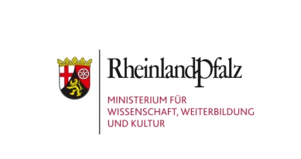



**Press Photos for »Barbara Hepworth. Sculpture for a Modern World«**

|  |  |
| --- | --- |
| **Image** | **Title** |
| http://images.tate.org.uk/sites/default/files/styles/thumbnail/public/wilmer63_1.jpg?itok=0HhXypEl | 1) Barbara Hepworth in the Studio Palais de Danse, St. Ives, at work on »Hollow Form with White Interior«, 1963 photo: Val Wilmer, ©Bowness |
| D:\Zwischenablage\Pressebilder BH_Mick Vincenz\Test-Presse_B-Hepworth\web-sized_30%\_MG_6462.jpg | 2) Barbara Hepworth, Sphere with Inner Form, 1963, The Withworth, Manchester, © Bowness, photo: Mick Vincenz |
| D:\Zwischenablage\Pressebilder BH_Mick Vincenz\B-Hepworth_Presse-Teil-2\web-sized_30%\_MG_6521.jpg | 3) Installation View Arp Museum Bahnhof Rolandseck 2016 with »Curved Form (Delphi)«, 1955 and »Configuration (Phira)« 1955, © Bowness, photo: Mick Vincenz |
| D:\Zwischenablage\Pressebilder BH_Mick Vincenz\Test-Presse_B-Hepworth\web-sized_30%\_MG_6484.jpg | 4) Barbara Hepworth, Curved Form (Trevalgan), 1956, Tate, © Bowness, photo: Mick Vincenz |
| D:\Zwischenablage\Pressebilder BH_Mick Vincenz\Test-Presse_B-Hepworth\_MG_6498-Korrektur-web-sized_30%.jpg | 5) Installation View Arp Museum Bahnhof Rolandseck with »Squares with Two Circles«, 1963, Tate, © Bowness, photo: Mick Vincenz |
| D:\Zwischenablage\Pressebilder BH_Mick Vincenz\B-Hepworth_Presse-Teil-3\web-sized_30%_3\_MG_6540.jpg | 6) Barbara Hepworth, Pelagos*,* 1946, Tate, © Bowness, photo: Mick Vincenz |
| http://images.tate.org.uk/sites/default/files/styles/thumbnail/public/entrance_to_flats_1.jpg?itok=vHPapcm- | 7) Barbara Hepworth, photo collage with »Helicoids in Sphere« in the entrance hall of flats designed by Alfred and Emil Roth and Marcel Breuer at Doldertal, Zurich 1939, The Hepworth Photograph Collection, © Bowness |
| D:\Zwischenablage\Pressebilder BH_Mick Vincenz\B-Hepworth_Presse-Teil-3\web-sized_30%_3\_MG_6548.jpg | 8) Installation View Arp Museum Bahnhof Rolandseck 2016, © Bowness , photo: Mick Vincenz |
| D:\Zwischenablage\Pressebilder BH_Mick Vincenz\B-Hepworth_Presse-Teil-2\web-sized_30%\_MG_6630.jpg | 9) Installation View Arp Museum Bahnhof Rolandseck 2016 with works by Barbara Hepworth and Ben Nicholson, photo: Mick Vincenz |
|  | 10) Barbara Hepworth, Large and Small Form, 1934, The Pier Arts Center Collection, Orkney, © Bowness |
| http://images.tate.org.uk/sites/default/files/styles/thumbnail/public/t03129.jpg?itok=0DTRu3EH | 11) Barbara Hepworth, Infant,1929  Tate, © Bowness |
| D:\Zwischenablage\Pressebilder BH_Mick Vincenz\B-Hepworth_Presse-Teil-3\web-sized_30%_3\_MG_6582.jpg | 12) Installation View Arp Museum Bahnhof Rolandseck 2016, with works by Alan Durst, John Skeaping and Barbara Hepworth, photo: Mick Vincenz |
| http://images.tate.org.uk/sites/default/files/styles/thumbnail/public/hepworth_photogram1_1.jpg?itok=8yvAfuaV | 13) Barbara Hepworth, Self-photogram, 1933, Tate Library and Archive: Papers of Dame Barbara Hepworth, © Bowness |

**Preview of Coming Exhibitions for 2016/2017**

**Still running from 2015 – annual theme »free space«:**

bis 16.10.2016 **Kunstkammer Rau 10:**

**Children‘s Lives between Wish and Reality**

**2016 – annual theme »Galerie Dada«**

14 February to 10 July 2016 **Genesis Dada. 100 Years of Dada Zürich**

22 May to 28 August 2016 **Barbara Hepworth. Sculpture for a Modern World**

4 June to 31 July 2016 **Youth Art Prize 2016**

30 July 2016 to 23 April 2017 **Arp Collection 2016**

21 August 2016 to 22 January 2017 **Other Realities**

23 September 2016 to 23 April 2017 **Ready for the Stage / Act I (1900-2016)**

11 November 2016 to 11 July 2017 **Ready for the Stage / Act II (1500-1900)**

**Kunstkammer Rau 10:**

**Menschenskinder. Children‘s Lives between Wish and Reality**

20. September 2015 bis 16. Oktober 2016

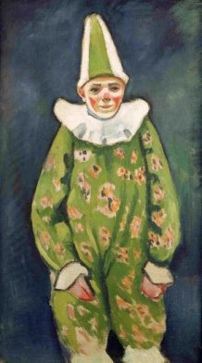August Macke, Clown in Green Costume, 1912

© Arp Museum Bahnhof Rolandseck / Rau Collection for UNICEF, photo: Mick Vincenz

Children were one of the main concerns of the art collector and philanthropist Gustav Rau, who worked in the Democratic Repubilc of the Congo as a paediatrician. This is clearly reflected in many of the paintings and sculptures in his high-quality art collection. After his death, he bequeathed his art works to UNICEF. In the 10th exhibition in the Kunstkammer Rau in the Arp Museum, a selection of works is presented in an exciting dialogue with prize-winning photographs from the international competition "UNICEF Photo of the Year" to mark World Children's Day 2015. The fascinating comparison between the historic paintings and outstanding reportage photos displays a focus on children and childhood – from the Middle Ages to the present day. They tell of the blessing of children in the works of Van der Plaes and Sjöström, but also portray the hard daily routine of many children in the slums and crisis regions of the earth in those of Michelin and Bleasdale. Viewers look over the shoulder of orphan girls in Amsterdam with Liebermann and those of present-day schoolchildren in Yemen with Boushnak. And they experience children's development from infancy to youth and learn something of the social role-playing and the lives of children across the ages.

**Genesis Dada. 100 Years of Dada Zurich**

14 February to 10 July 2016

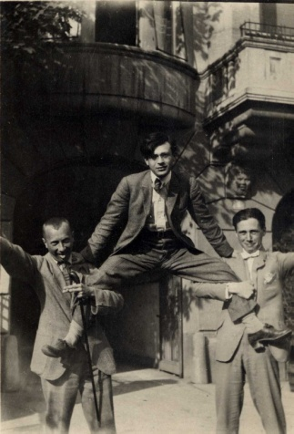

Hans Arp, Tristan Tzara, Hans Richter in front of the hotel Elite, Zurich 1918  
© Stiftung Arp e.V. Rolandswerth / Berlin, unkonwn photographer

Founded on 5 February 1916 by Hugo Ball, Emmy Hennings, Marcel Janco, Tristan Tzara, and Hans Arp in Zurich's "Cabaret Voltaire," Dada is one of the most progressive art movements of the 20th century. To mark its centenary, the Arp Museum Bahnhof Rolandseck resurrects Dada's foremost birthplaces: the legendary artist nightclub "Cabaret Voltaire" and the bourgeois "Galerie Dada". Setting off from these two poles, the Dadaists revolutionised the international art world within a short span of time. Aside from their own works, they also showed such international avant-garde artists as Pablo Picasso, Giorgio de Chirico, and Paul Klee, all of whom are represented in the present exhibition. The artworks are embedded in a lively staging that sheds light on the complex social and intellectual soil from which Dada sprang. Subjects ranging from psychology and literature to political and sociocultural revolts reflect the zeitgeist and provide for a vivid presentation of Dada's origins.

In collaboration with Cabaret Voltaire, Zurich

**19th Youth Art Prize 2016**

4 June to 31 July 2016

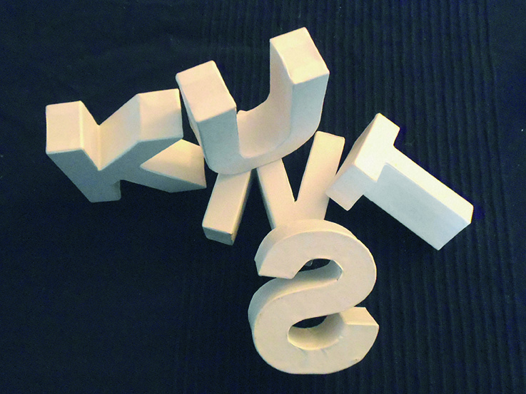In keeping with "Galerie Dada", this year's theme at Arp Museum Bahnhof Rolandseck, the 15-to-19-year-old competitors for the 19th Youth Art Prize awarded by the BBK Bonn, Rhein-Sieg e.V. all grappled with Dadaism and its influence on current trends in art. The social and political conditions that served as the breeding ground for Dadism are still highly relevant even today. Such artistic means of expression as graffiti or rap have their roots in Dadaism, and a sizeable portion of today's contemporary artwork would not have been conceivable without these ideas having been formulated in 1916. The results selected from a great deal more than 130 young artists afford a very young view to Dada that ranges from the small-format drawings via collages and a stop-motion film up to large-format objects carried out with various techniques and which make use of various possibilities of expression.

**Arp Collection 2016**

30 July 2016 to 23 April 2017

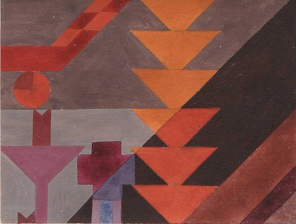

Sophie Taeuber-Arp, Composition with diagonals and small transparent Circle, 1916-18 © Collection Arp Museum Bahnhof Rolandseck, photo: Mick Vincenz

Also in keeping with this year's "Galerie Dada" theme is the presentation of the Arp Collection under the banner of this pioneering art movement during World War I. The show is a continuation of the previous exhibition "Genese Dada", which already introduced Hans Arp and Sophie Taeuber-Arp as protagonists of Dada's early years in Zurich. Using examples from the collection, the exhibition shows the origins of numerous of Arp's and Taeuber-Arp's principles on art dating from this short artistic phase in 1916/17 and how since then, they have left their marks on the development of their respective overall work. Thus, "Dada" runs like a red thread throughout the exhibition, repeatedly enabling these references to art (in images, poetry, and often humourously) to function as bridges in their early Dadist works. Arranged into individual themes such as relief, composition, collage, language, dance, etc., impressive insights open up into these unusual creative works.

In addition, the two exhibition cubes will show the legendary Zurich artists' cafe "Cabaret Voltaire", which deals with the theme of stage as well as Sophie Taeuber's marionettes for the play "König Hirsch" that focus on the theme of dance. The cabinet room containing texts and quotes by Hans Arp and his artist colleagues is dedicated to the numerous innovations they contributed to the field of abstract language.

**Other Realities**

21 August 2016 to 22 January 2017

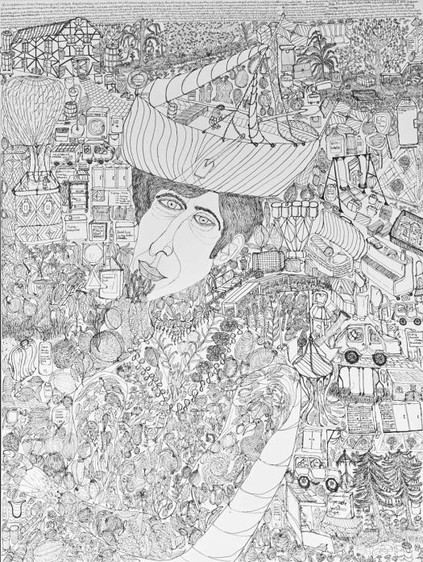Daniel Shoa, Daniel‘sWorld, 2015 (Detail), © atelierblau, photo: Stefan Ahlers

For the Dada Year 2016, the exhibition "Other Realities" focuses on art that comes about beyond the established structures of the art system. For it was none other than the Dadaists who questioned the traditional notion of art in 1916 and who began to "remove the boundaries" for this and to create artistic forms of expression outside of what was known until then. On display are works by artists from six studios at the State Association of the "Lebenshilfe Rheinland-Pfalz e.V." and the Ebernach Monastery in Cochem. The exhibition addresses the interest shown in the untrained, creative power of people with emotional or mental disorders, something that goes back as far as the early 20th century. In creatively grappling with one's own inner constitution, it is not the person as a patient but as an artist who stands in the foreground. The exhibition deals with these worlds of experience in painting, drawing, and sculpture and covers themes such as Myself and the Others, Sexuality, and the free, gestural form.

**Ready for the Stage / Act 1 (1900-2016)**

23 September 2016 to 23 April 2017

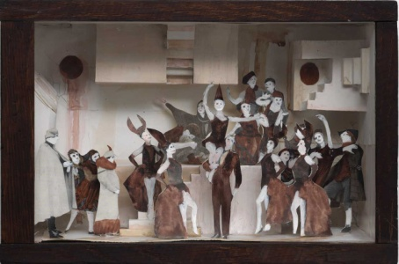Marcel Dzama, MD/Dio 18, Let mischance be a slave to patience, 2010, Collection Schnetkamp, © Marcel Dzama, Sies + Höke, Düsseldorf, photo: Achim Kukulies

To commemorate this great Dada anniversary year in 2016, and being inspired by the legendary "Cabaret Voltaire" in Zurich, two consecutive and related exhibitions are dealing with the theme of the stage in the visual arts from the 16th century up to the present day. Thus, for the first time in Germany, the changing relationship between painting and stage are being shown in their respective historical contexts in an exhibition project that is at once comprehensive and crosses the genres. The show "Ready for the Stage / Act 1 (1900 – 2016)" comprises works from Classical Modernism up to contemporary art. Using stage models, costumes, installations, video works, but also painting and sculpture, the relationships between the performative and the visual arts will be shown in their many facets. A portion of the objects on display takes up the theme of theater in reproductions or performances; another part has come about in connection with actual stage productions.

On display, among other things, are works by Piet Mondrian, Vladimir Tatlin, Daniel Spoerri, Andor Weininger, Nadja Schöllhammer, Markus Lüpertz, Alexandra Hopf, Torsten Jurell, Leiko Ikemura, Bill Viola, Arnulf Rainer, Claus Richter, Irmel Droese, Marcel Dzama and Marvin Gaye Chetwyn.

**Ready for the Stage / Act 2 (1500-1900)**

1 November 2016 to 11 June 2017

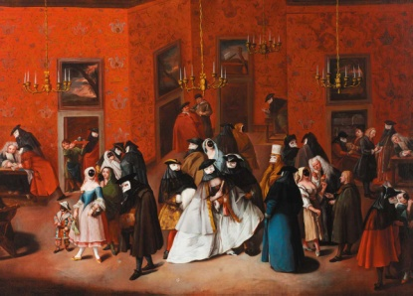

Pietro Longhi od. Giuseppe de Gobbis, Il Ridotto, ca. 1750, Arp Museum Bahnhof Rolandseck / Rau Collection for UNICEF, photo: Horst Bernhard

From their very beginnings, there has always been a particularly active exchange between the visual arts and theater. The central perspective of the early canvas paintings forms the main point of departure for Baroque theater. In addition, many painters and architects worked as festivity and stage decorators for the theater. They were familiar with the literary material and integrated this into their pictures. And vice versa, since the Renaissance, comic and tragic narrative types and characters of the theater, for example from the Commedia dell‘arte and popular theater, were taken over by the visual arts. These two strands will be traced from the middle ages up to contemporary art in two acts staged in the Kunstkammer Rau and on the Contemporary Level of the Meier building. Whereas the Kunstkammer Rau concentrates on stage models and costumes, the view to present-day developments deals with the three-dimensional stage, translating the influences of the visual arts into the performative arts. In doing so, the mutual relationships between the two exhibition areas become clear.